**CLOUD COMPUTING ASSIGNMENT -2**

***Samhitha Tummanapalli***

***Student ID:16246162***

Google Cloud Platform:

On successful account creation

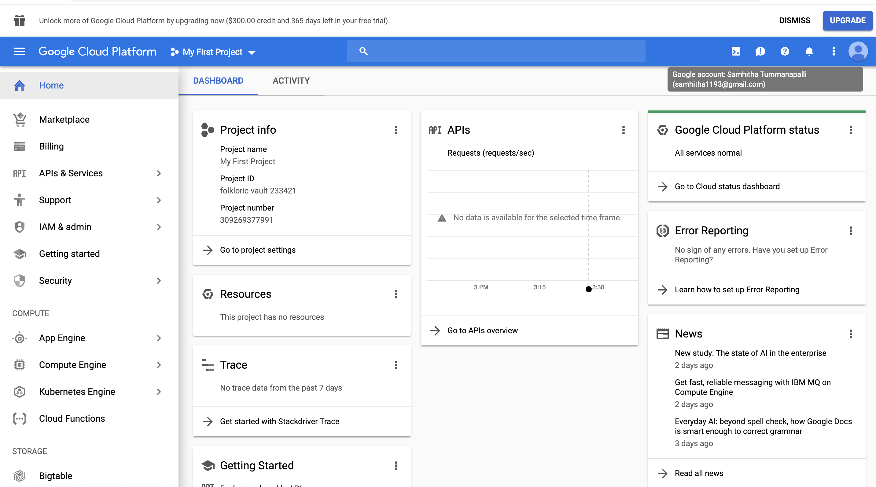

Amazon Web Service :

On successful account creation:



Microsoft Azure:



Execution:

Google Cloud Platform:

Click on Compute Engine -> VM Instances

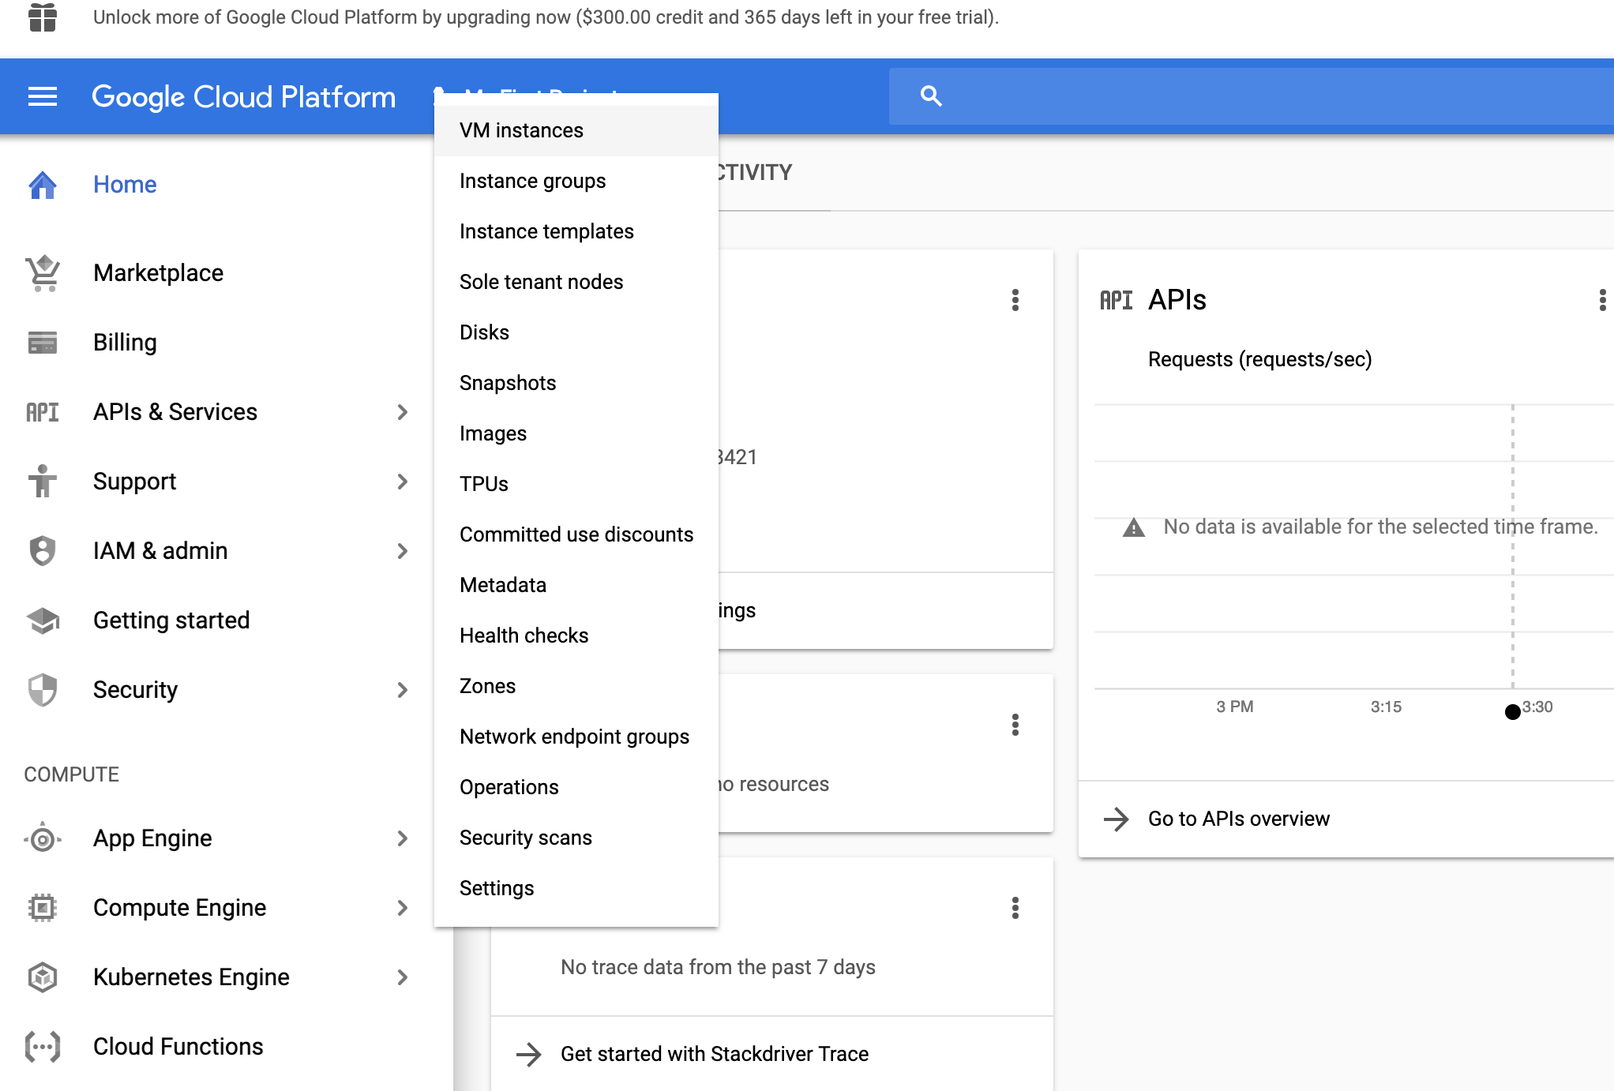



Click on Create to create an instance

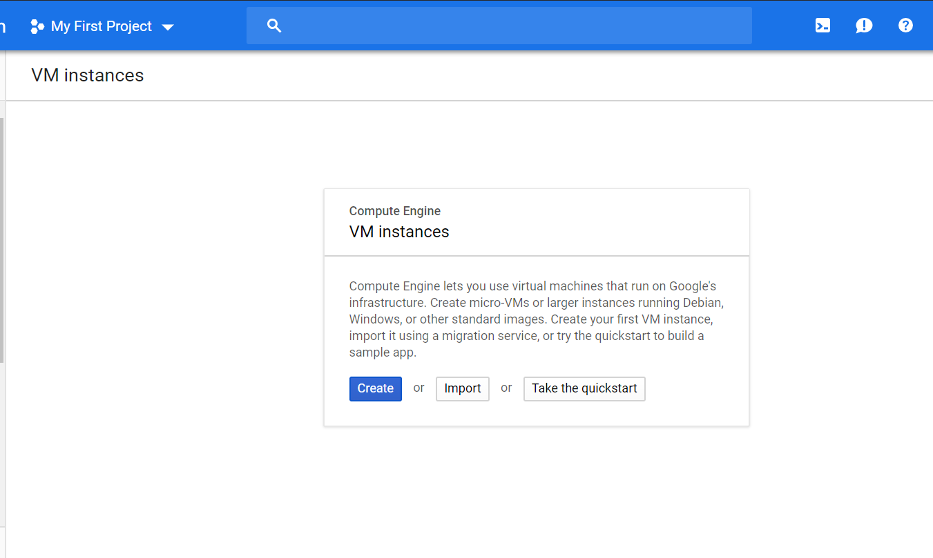

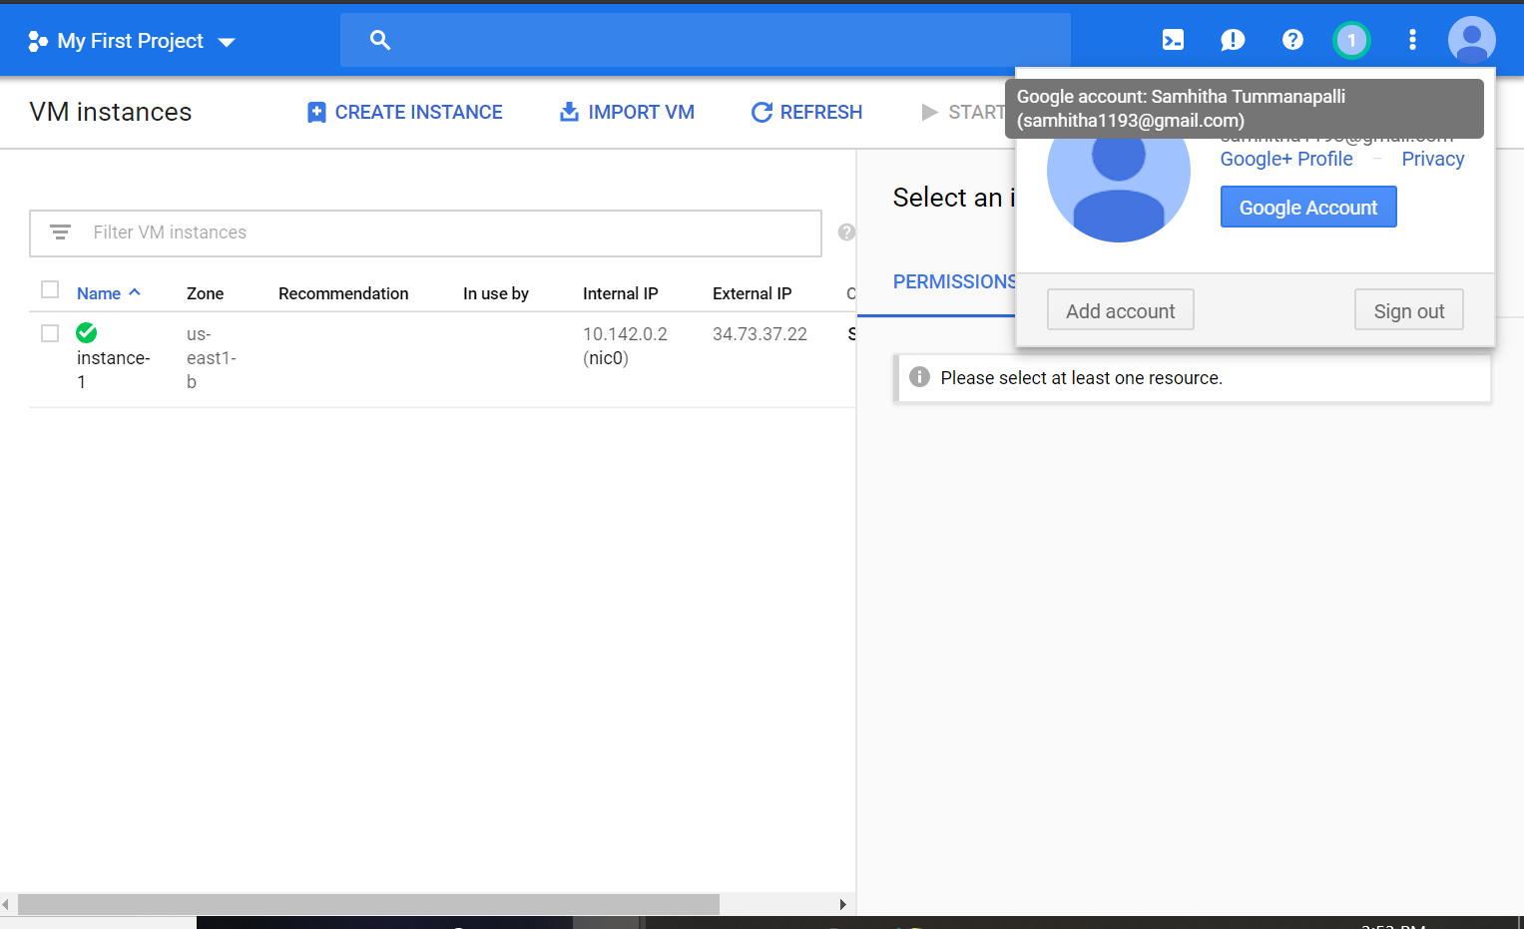

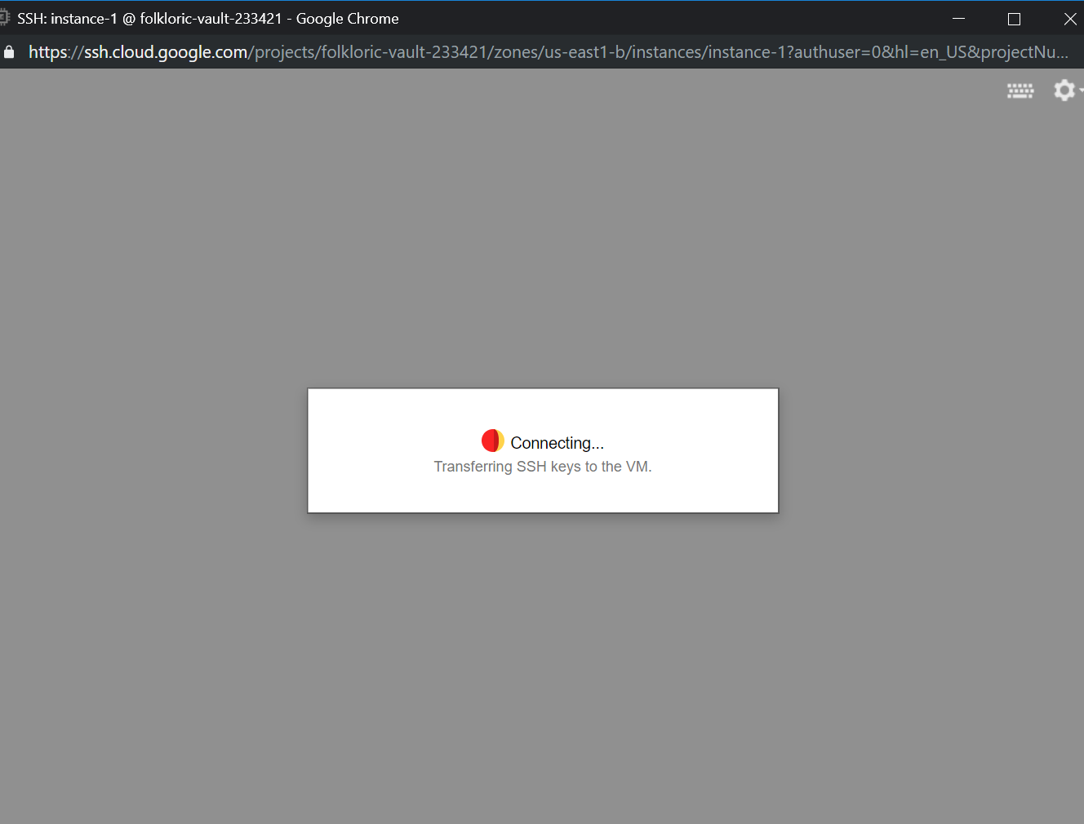

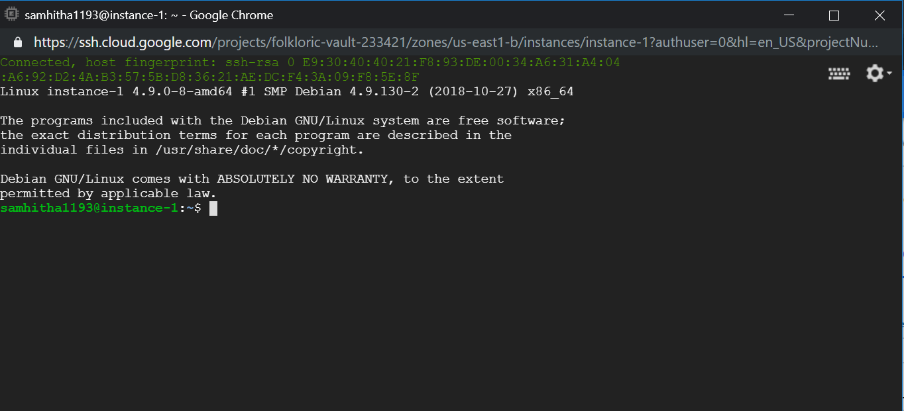

Installing the apache2

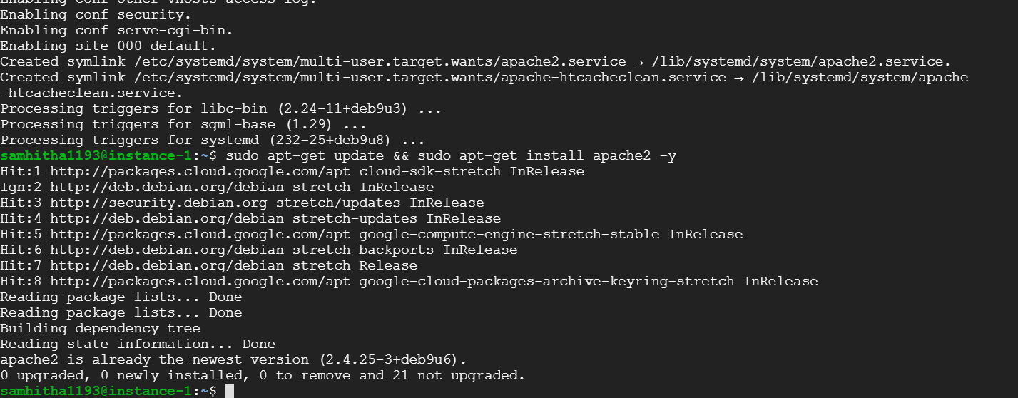

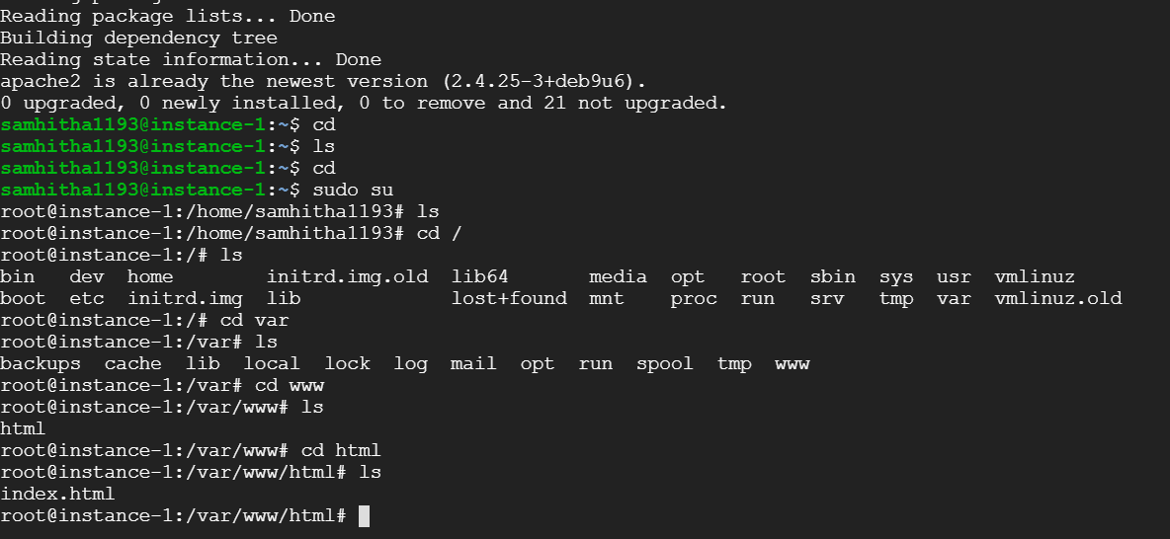

Open the editor using sudo nano index.html command to rewrite the code

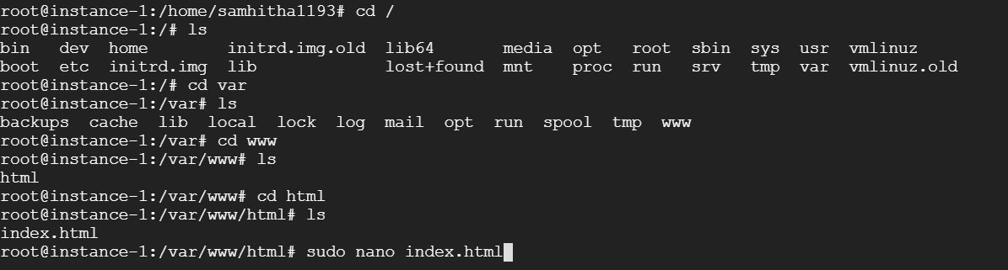

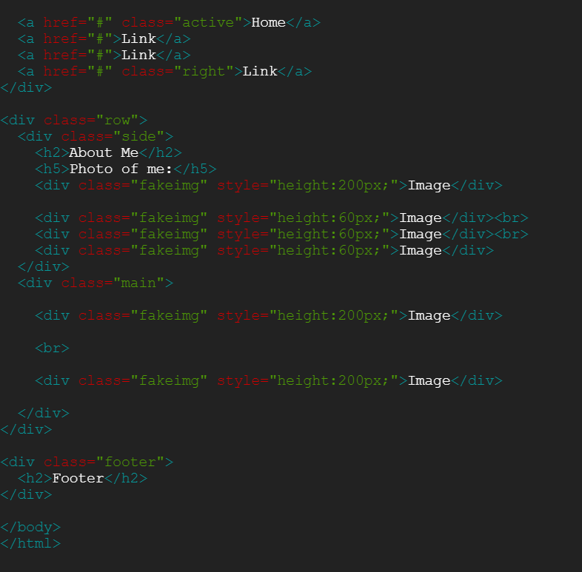

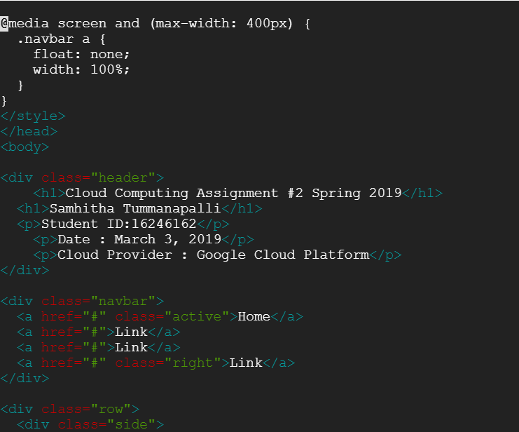

Double click on the External IP address to launch web server

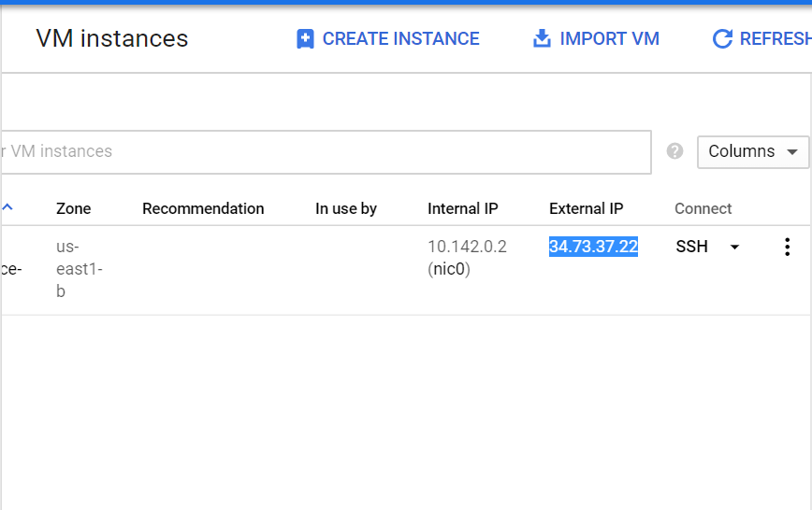

Web server launched

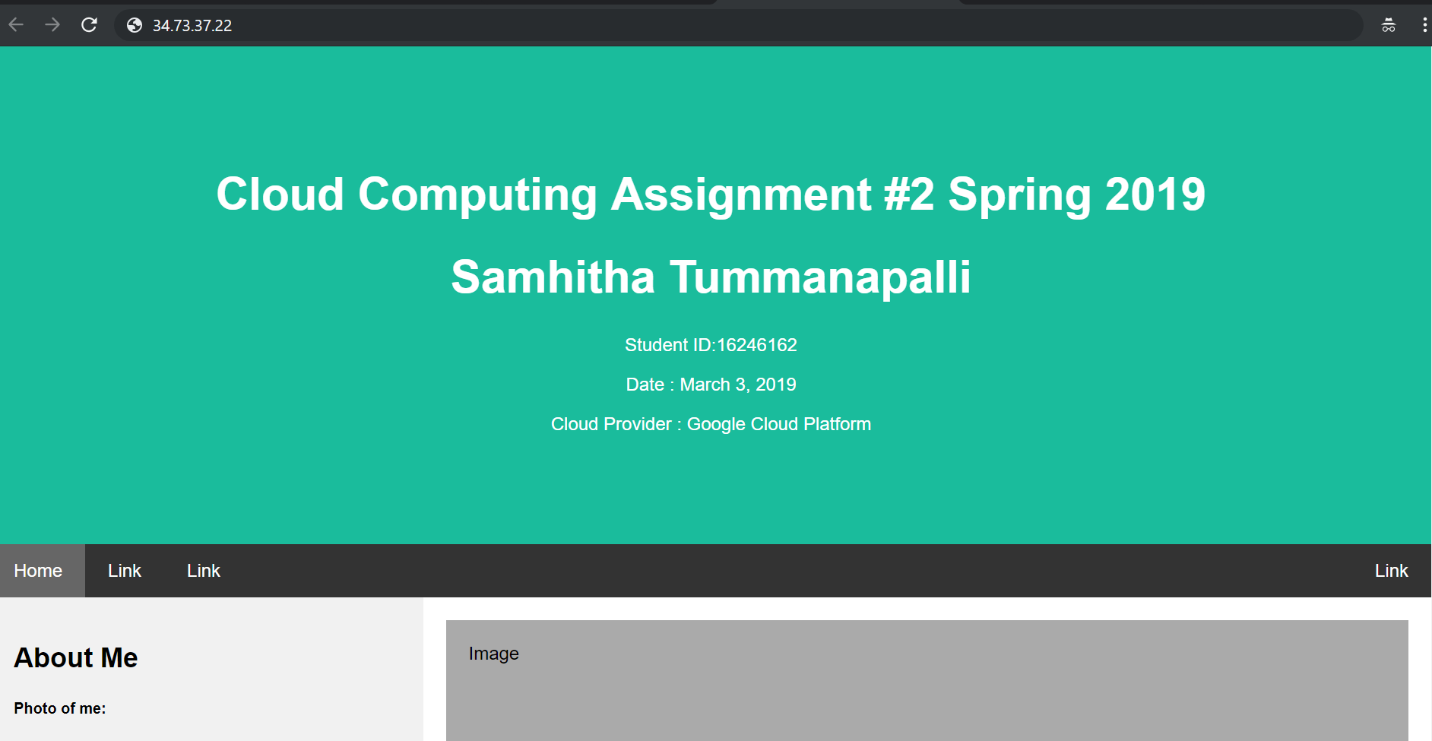

Amazon Web Services:

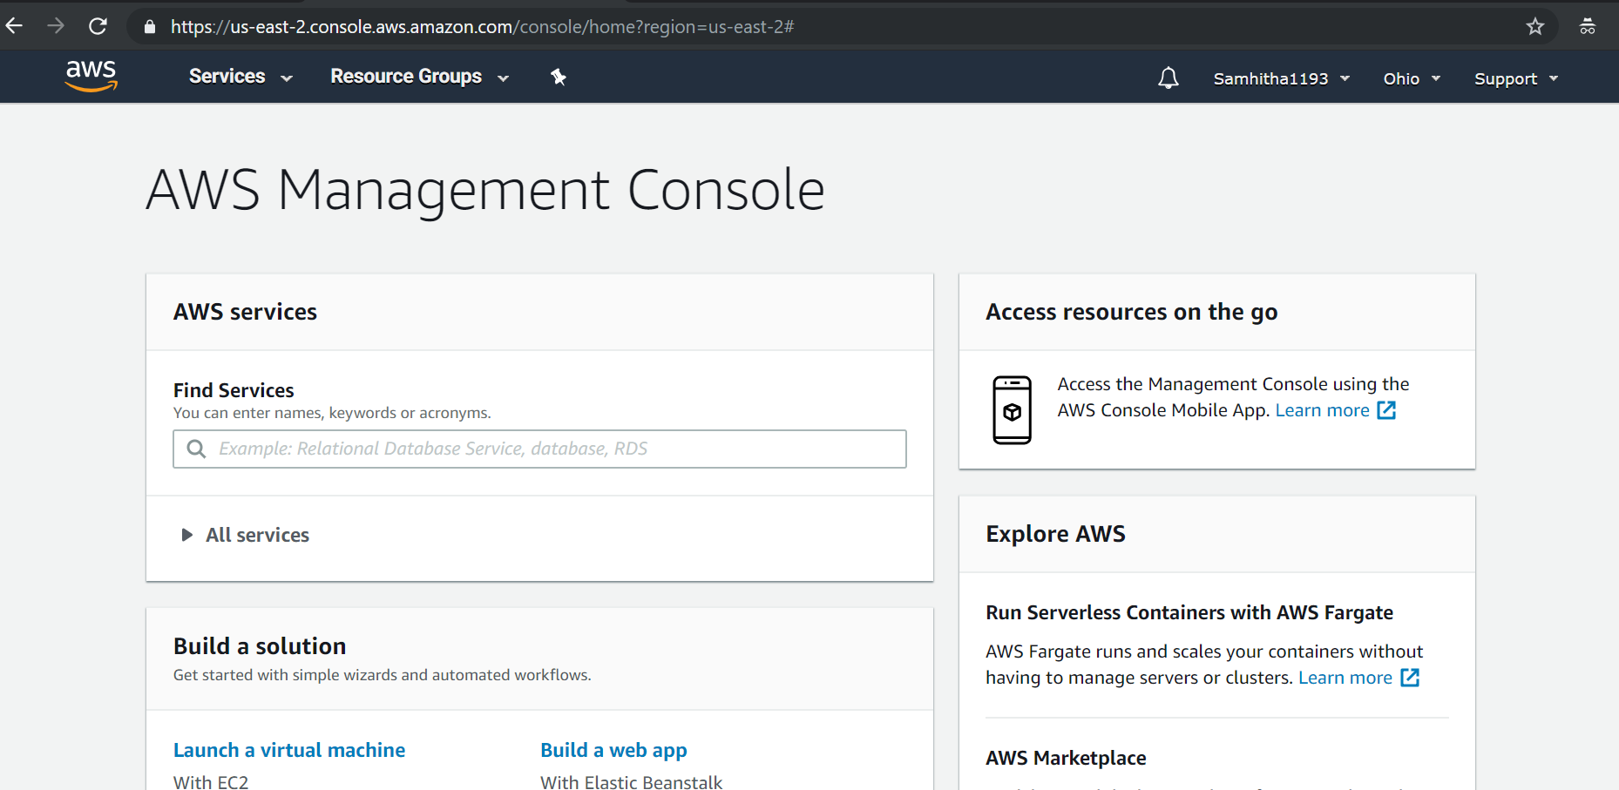

Click on Services -> EC2

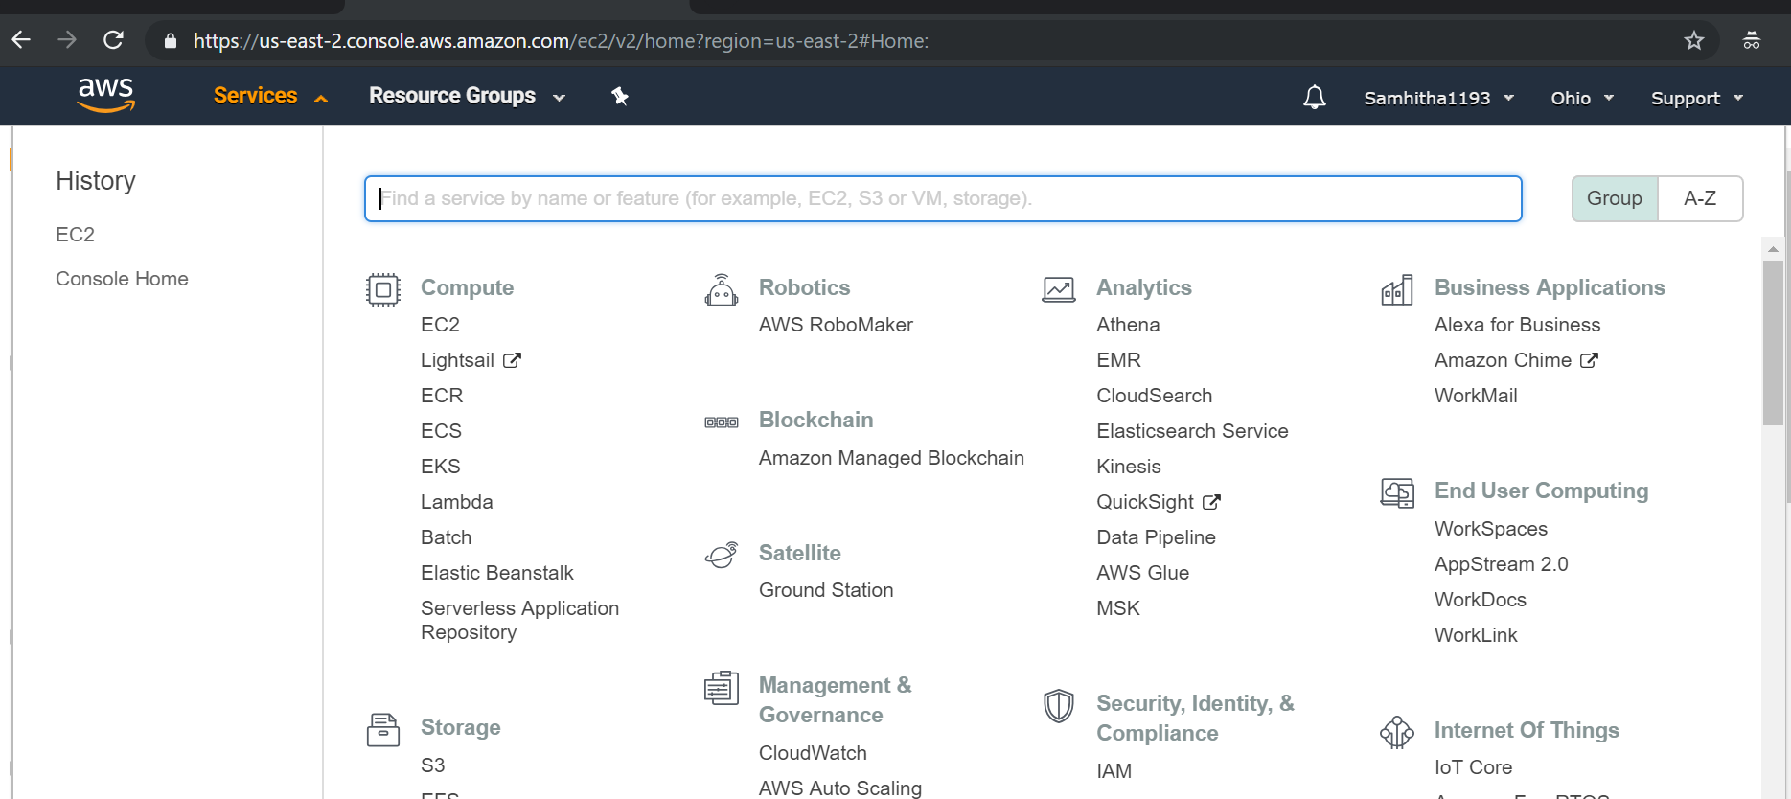

Click on Launch instance

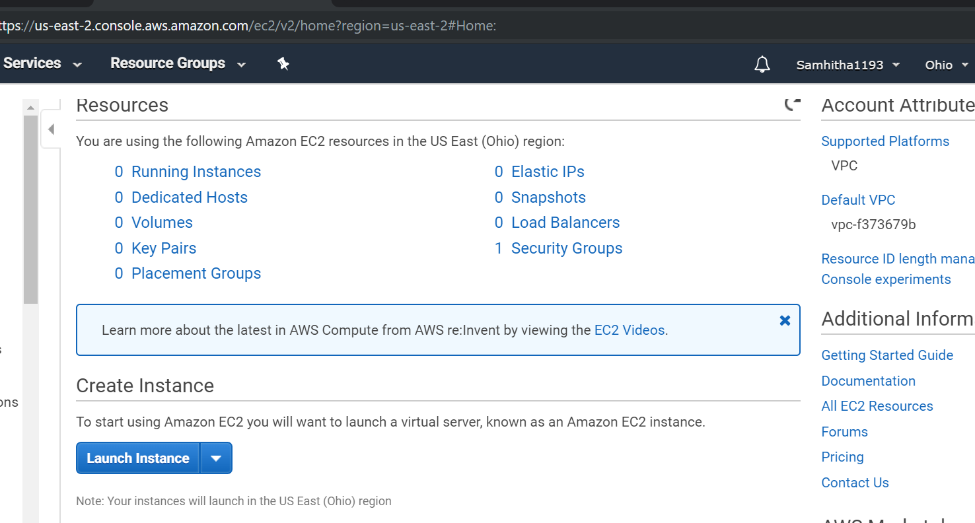



Choose the first AMI

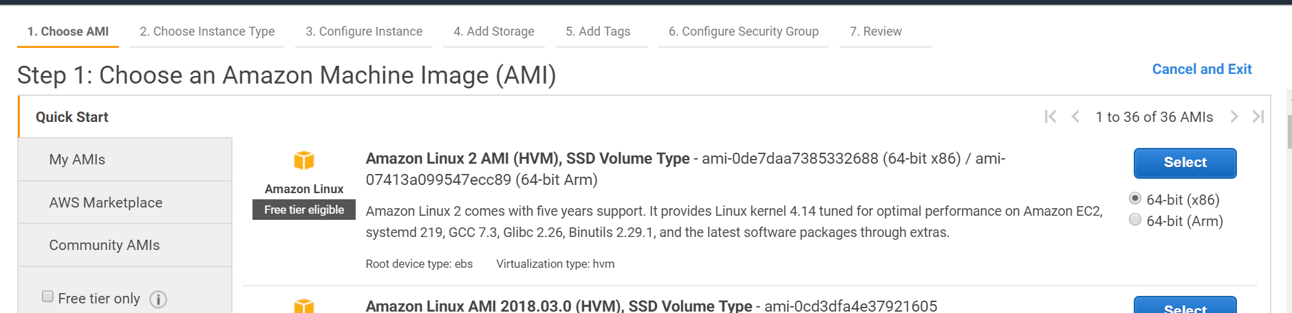

Choose free instance type

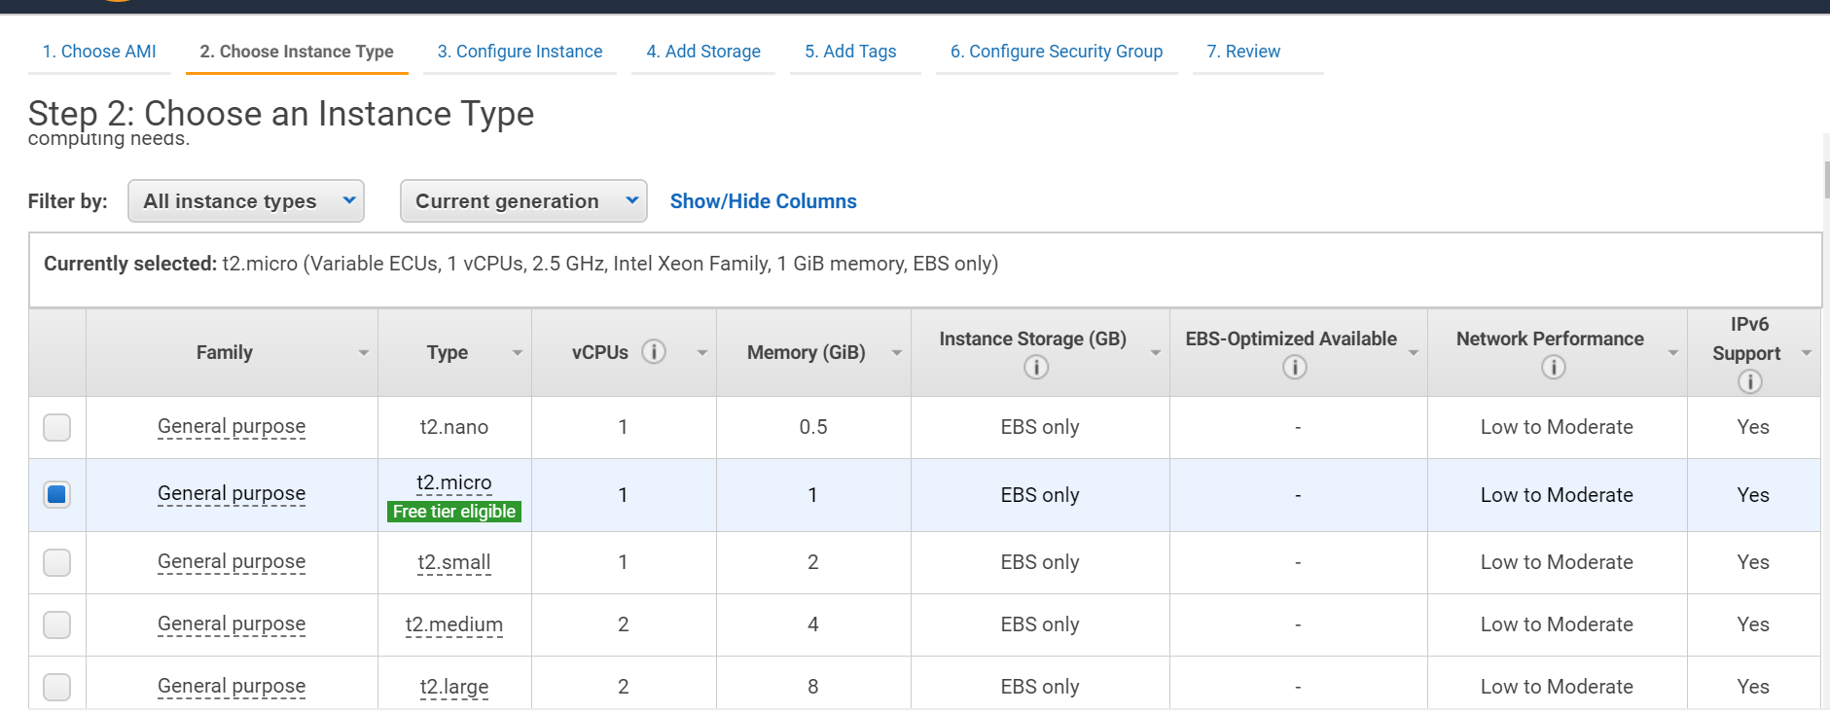

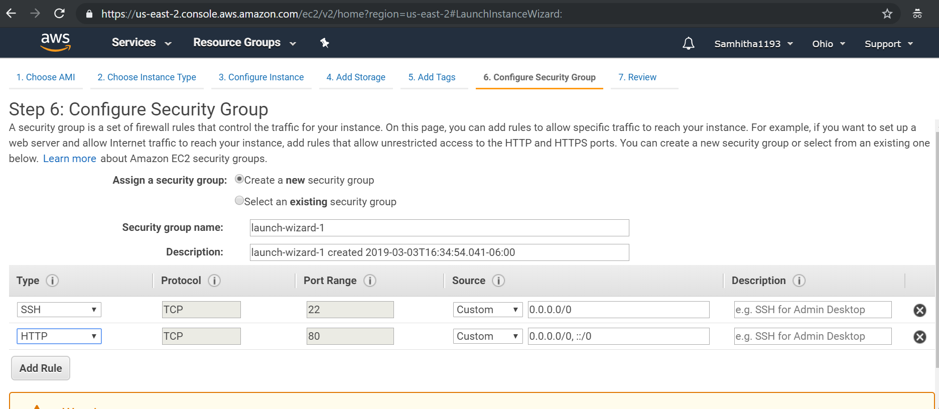

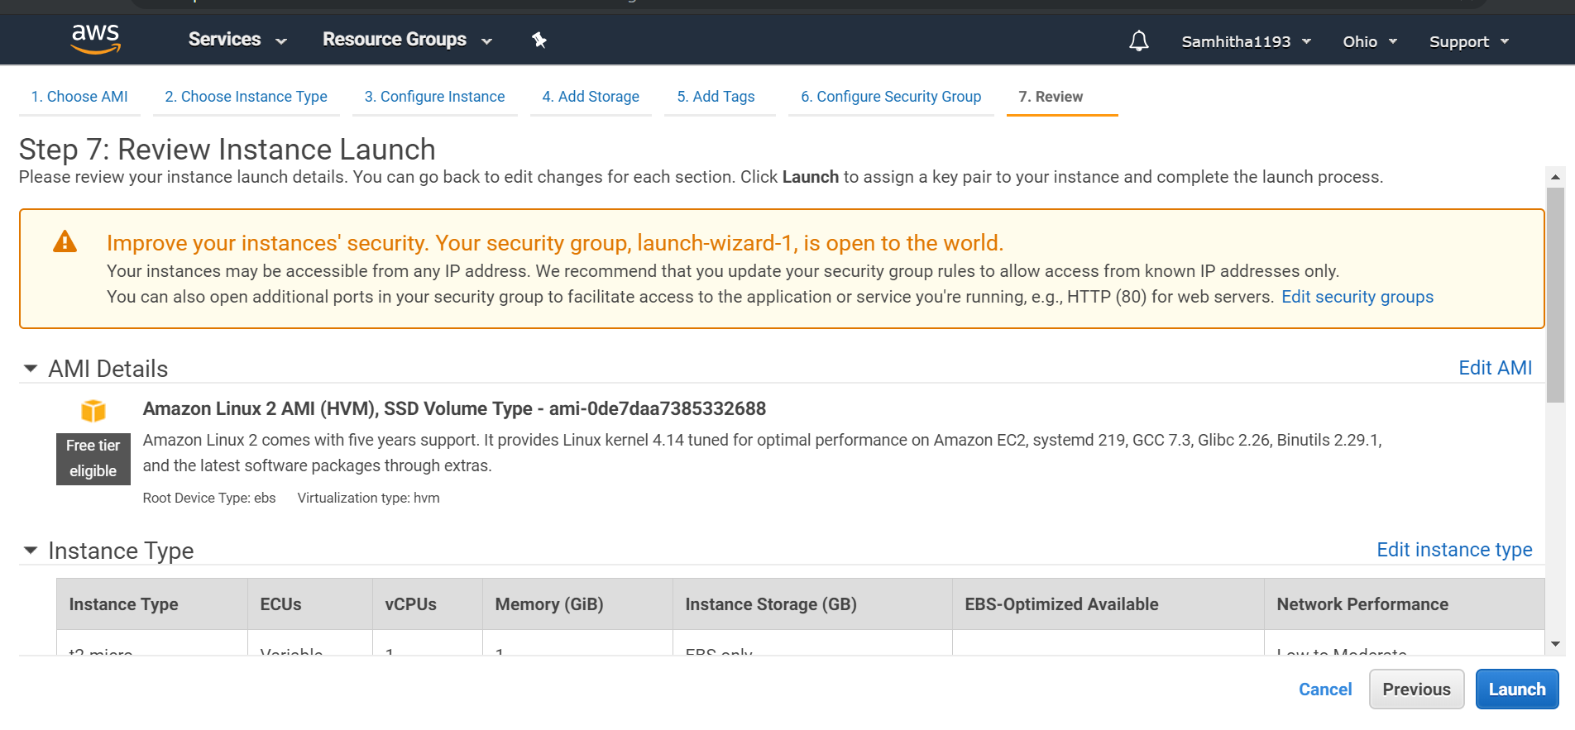

After Launch , a pop-up opens. Select ‘create a new key pair’ and provide a name for it. Click on download key pair which will be saved as .pem file.

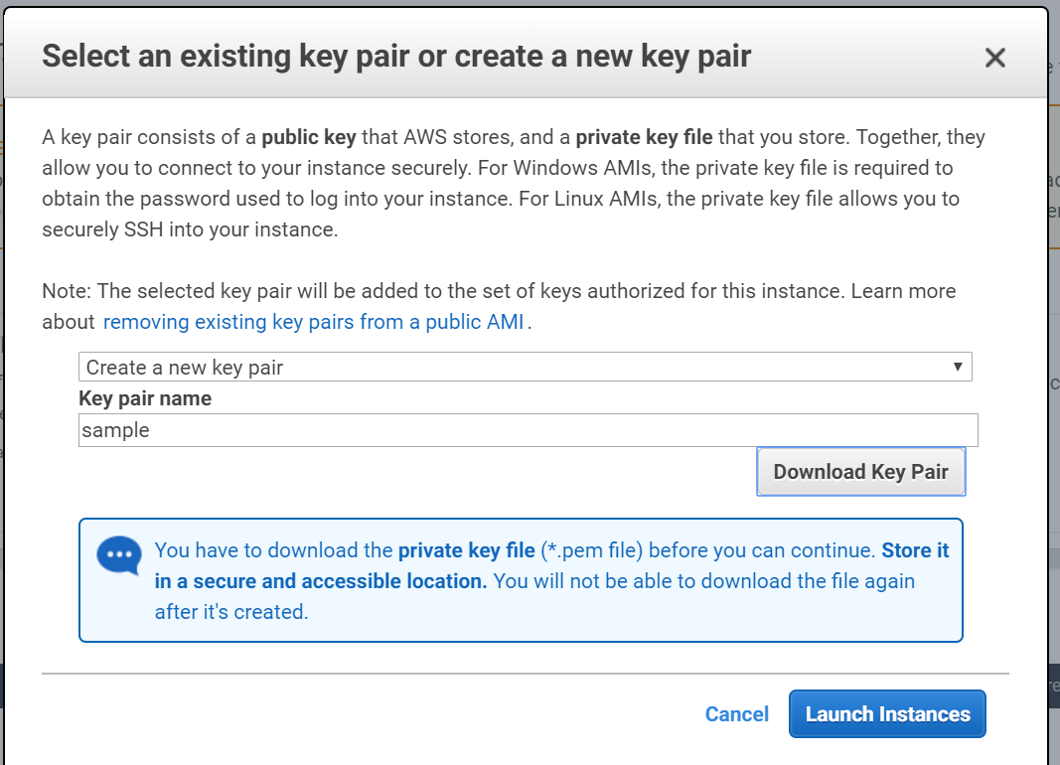

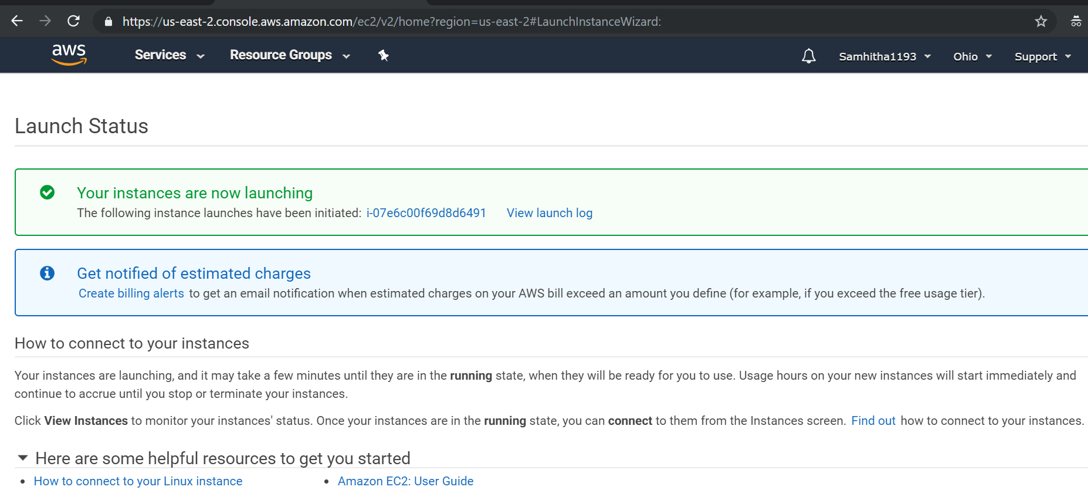

After successful launch , instance is created.

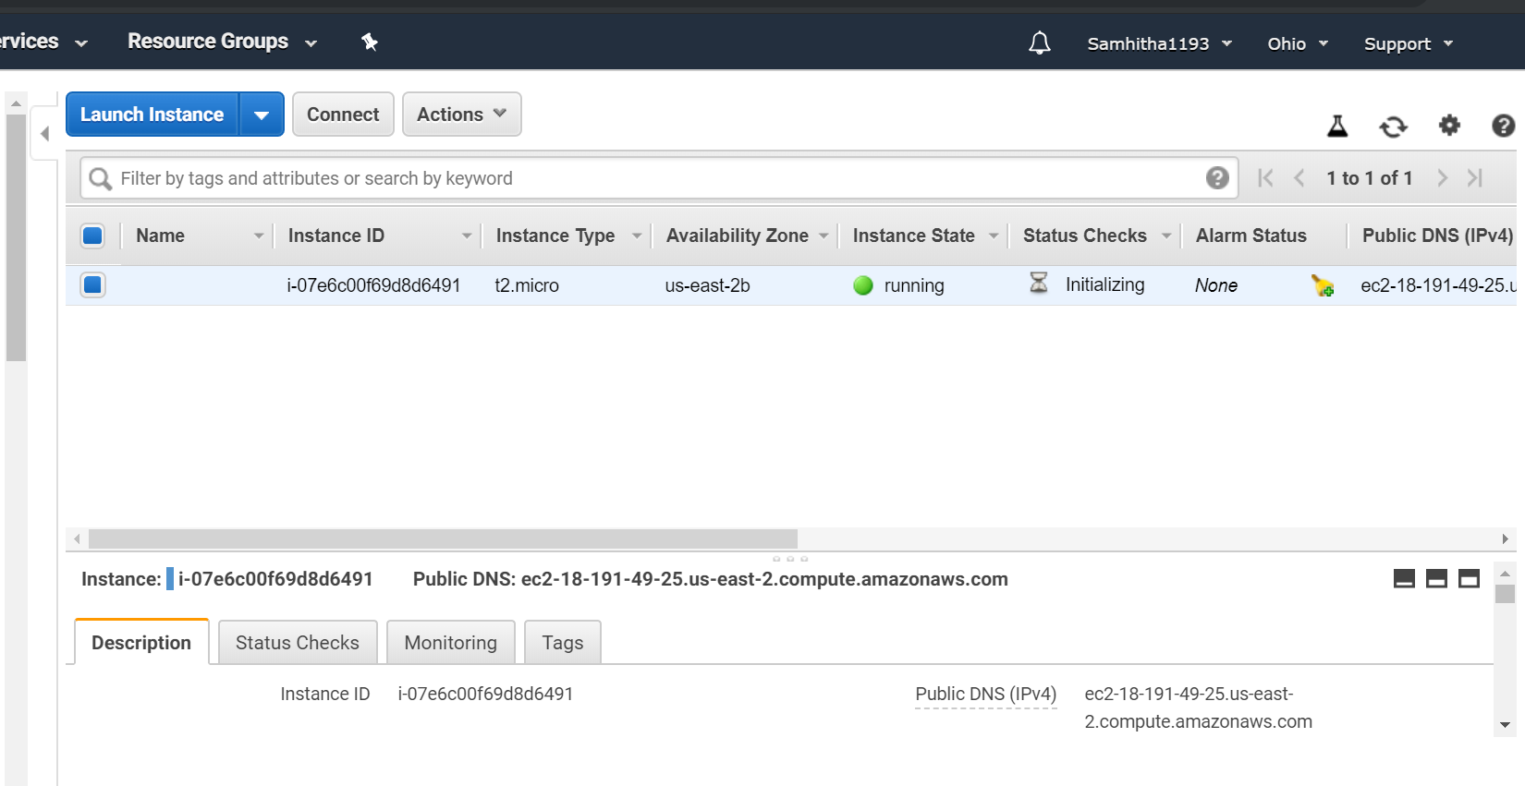

Use putty key generator to convert .pem file to .ppk file.

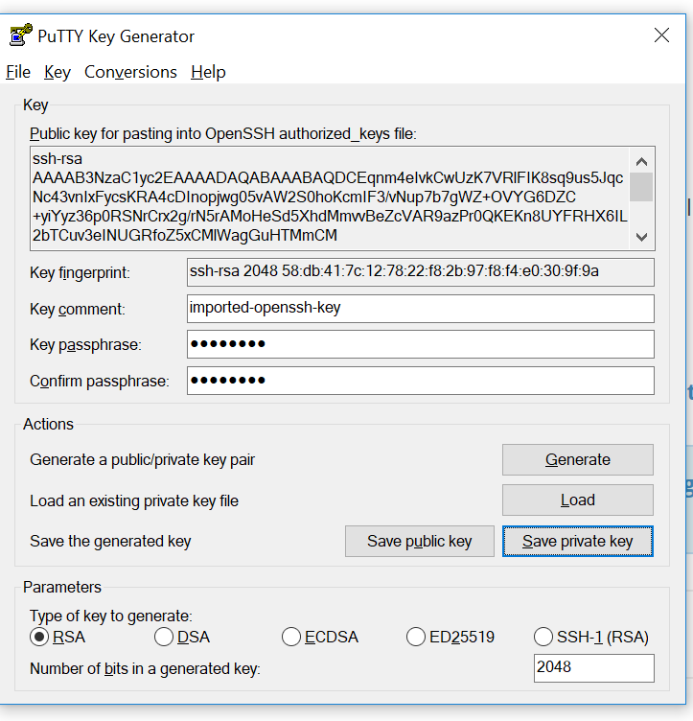

Now using Putty application, upload the .ppk file and launch the amazon prompt.

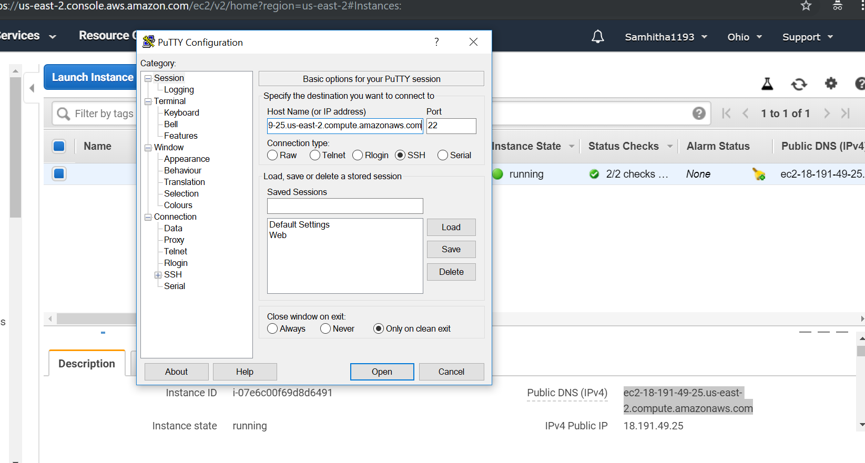

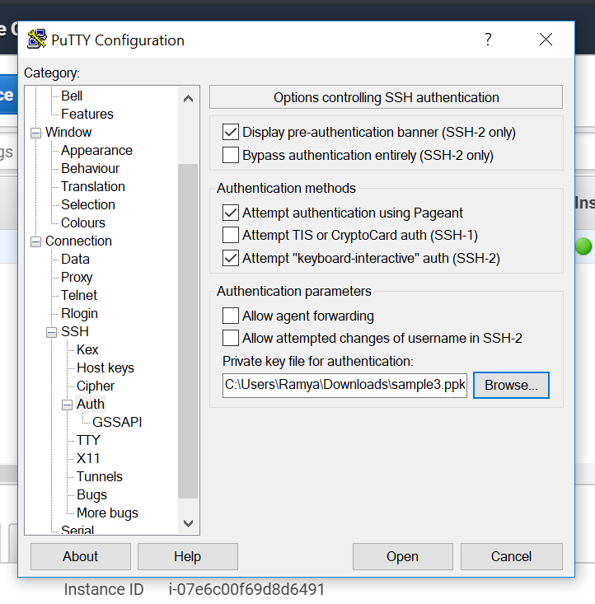

Amazon Prompt successfully launched.

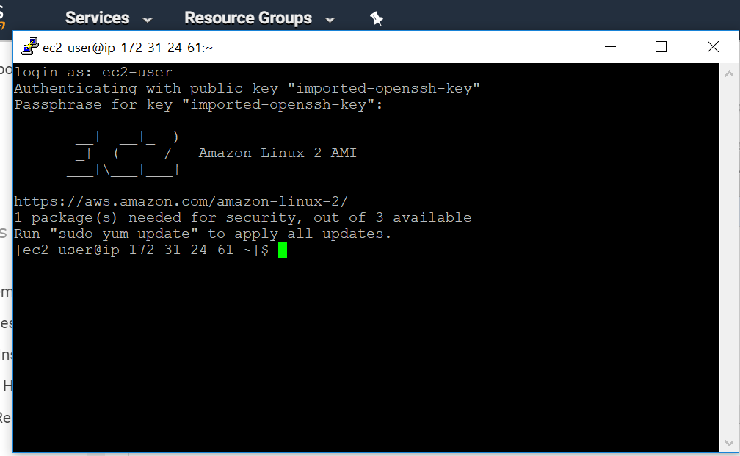

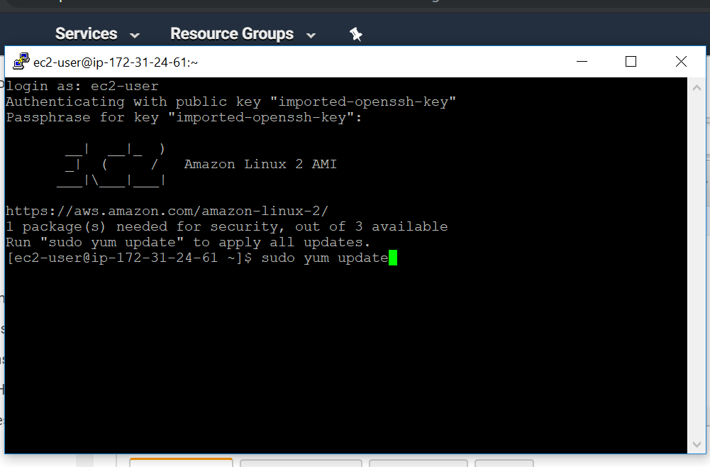

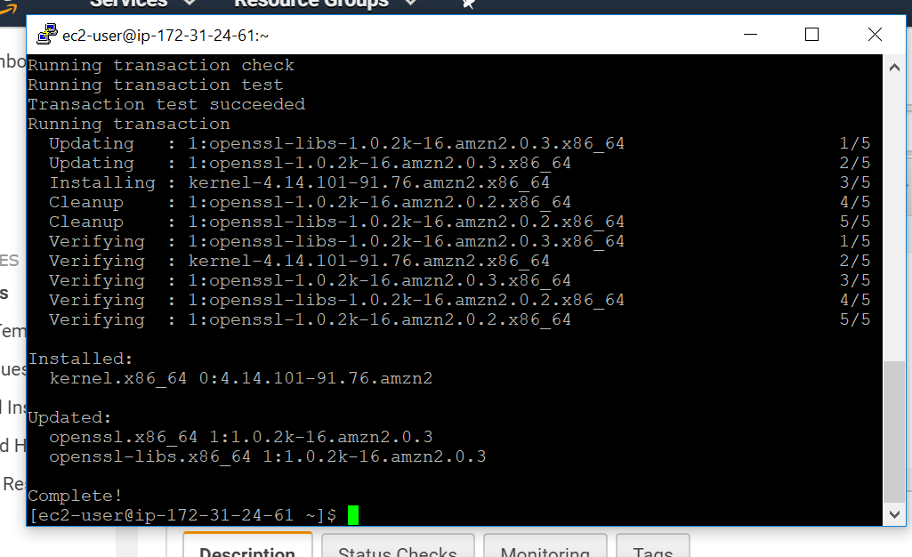

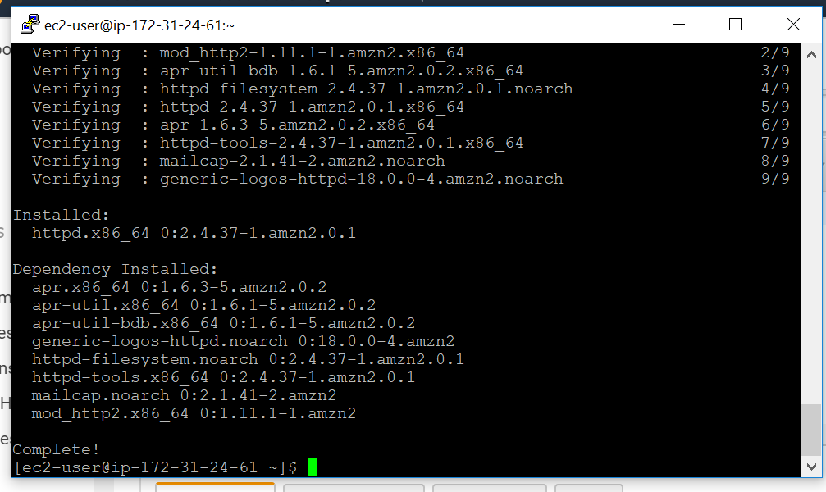

Install httpd

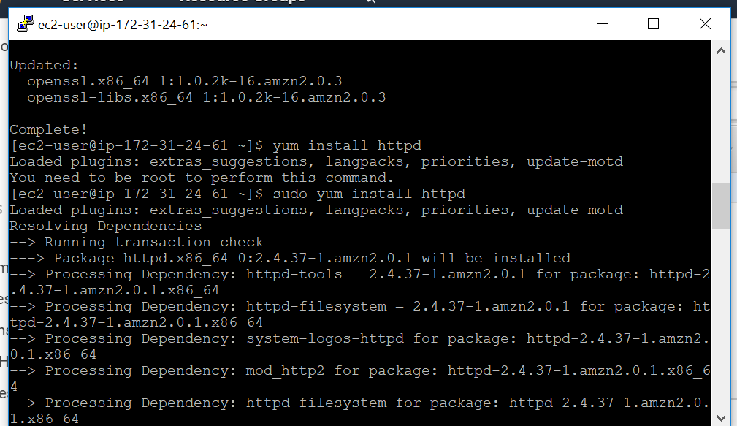

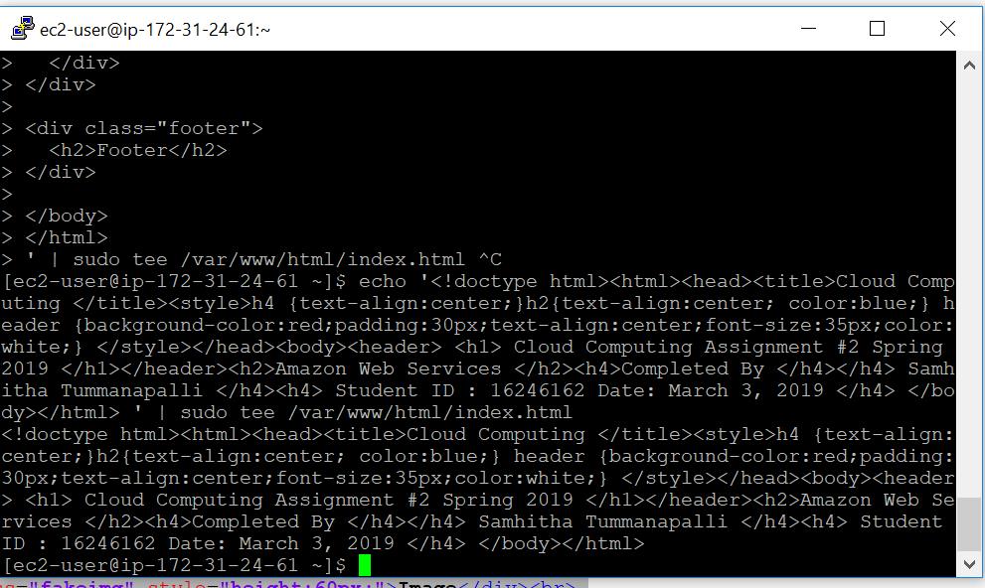

Launch web server

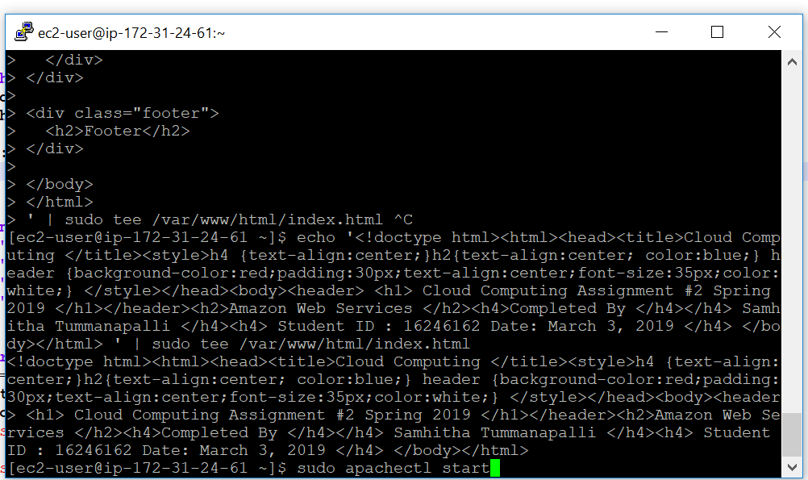

Copy the IPV4 address and paste on a web browser

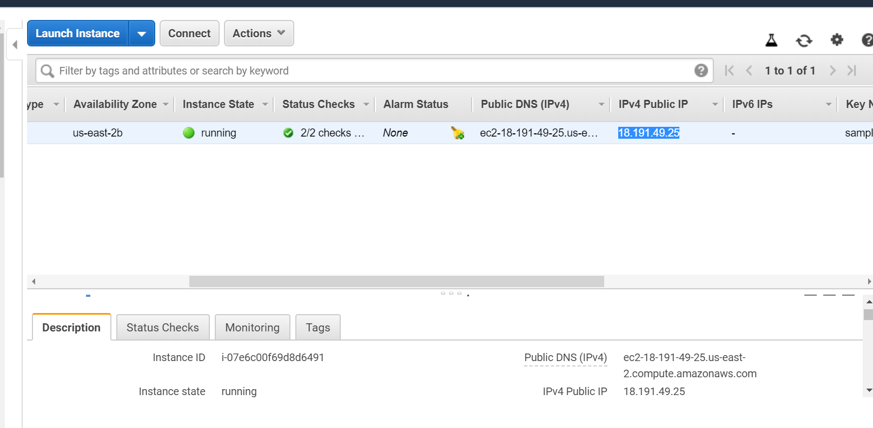

Successfully launched

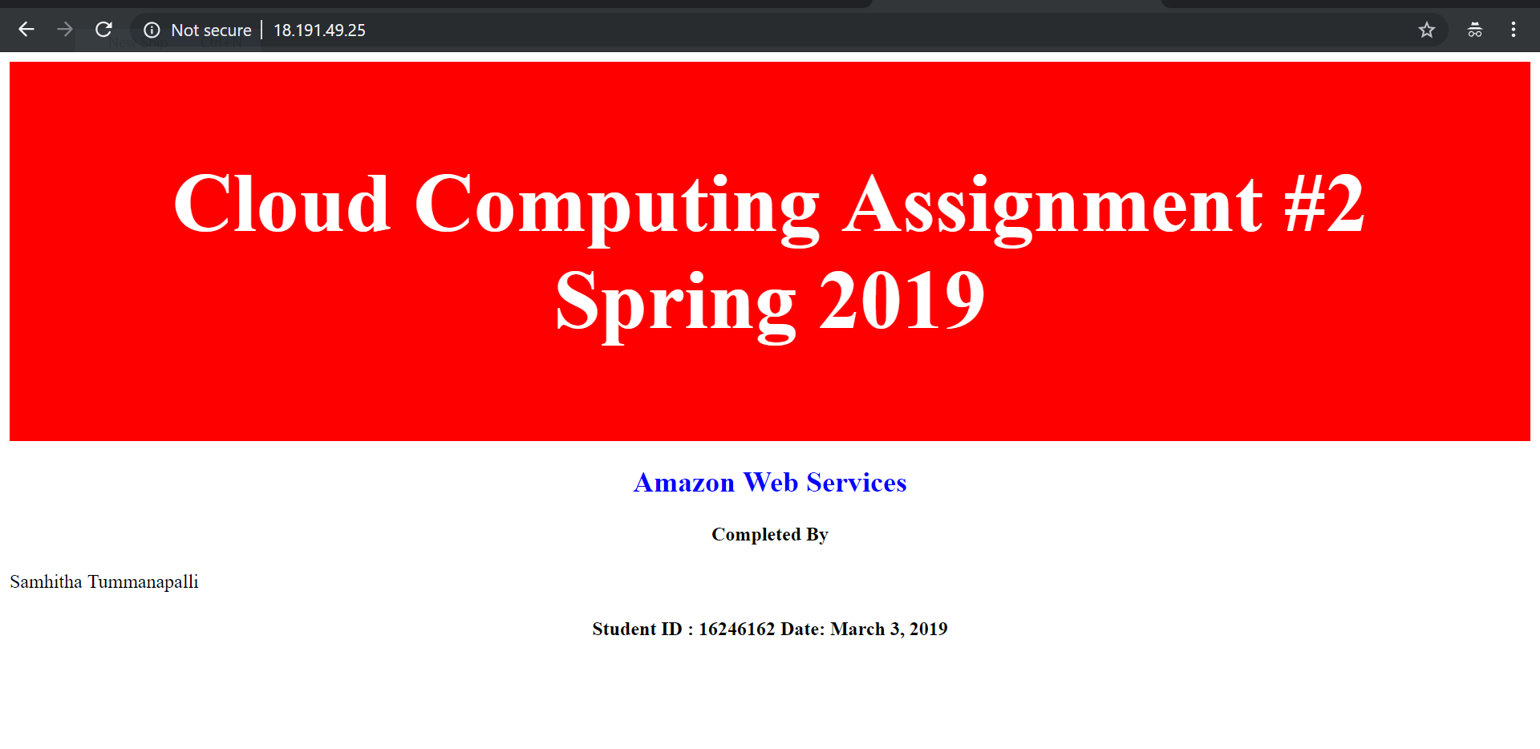

Microsoft Azure:

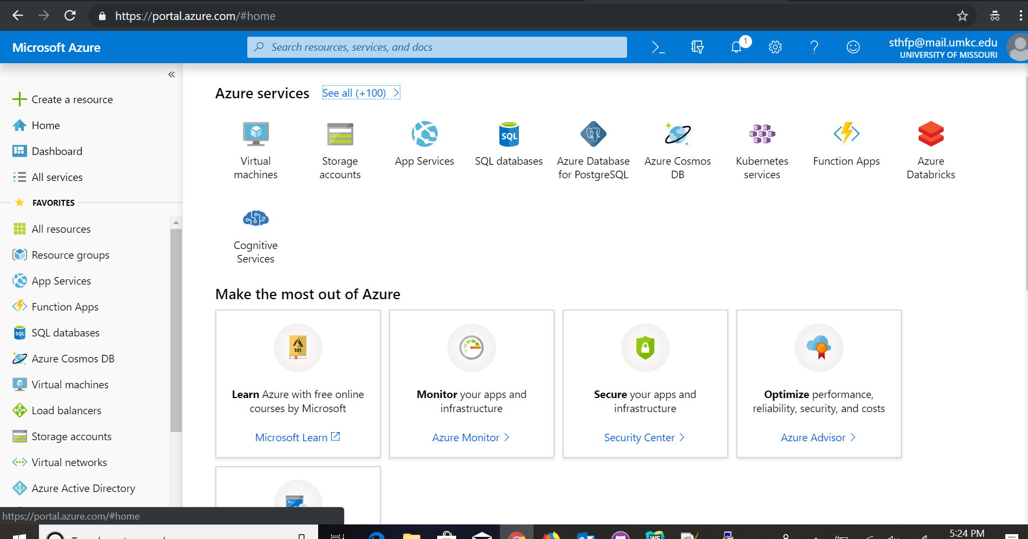

Click Virtual Machines-> create

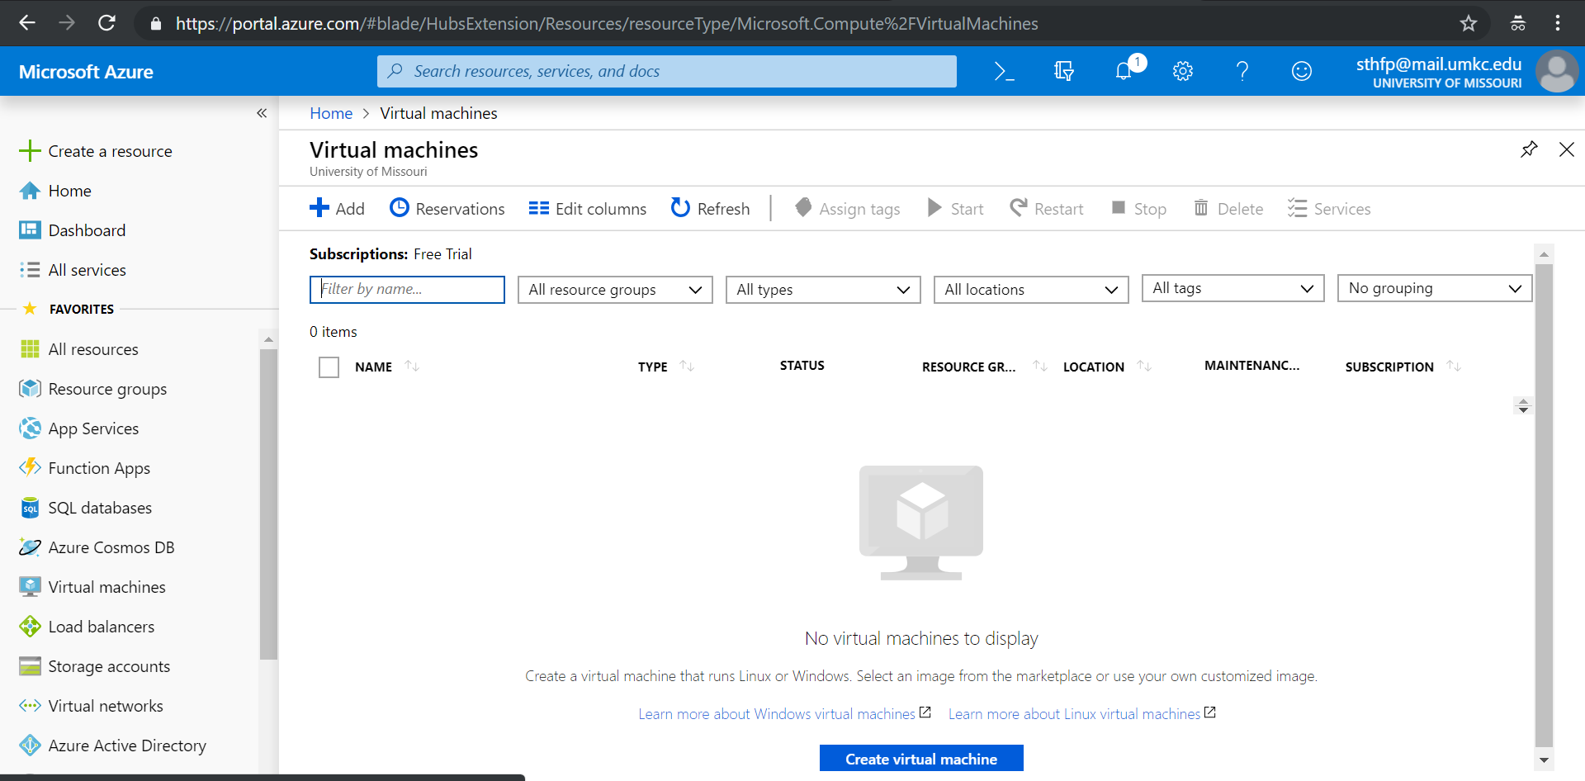

Select three inbound part rules – http, ssh,rdp

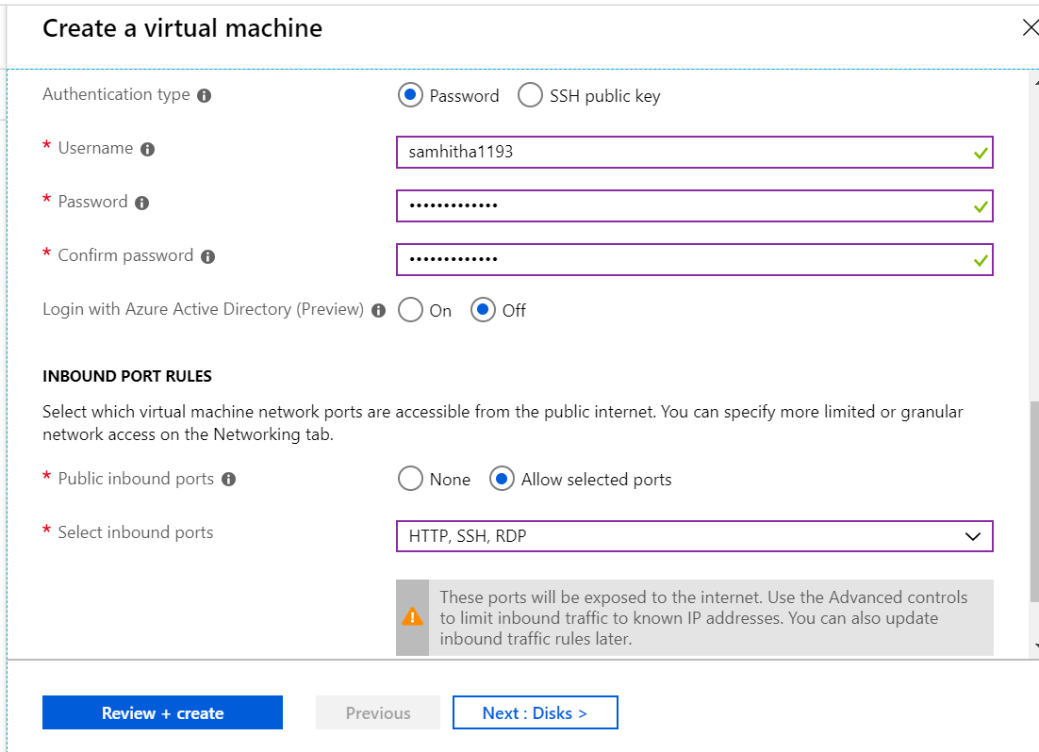

Copy the local host address

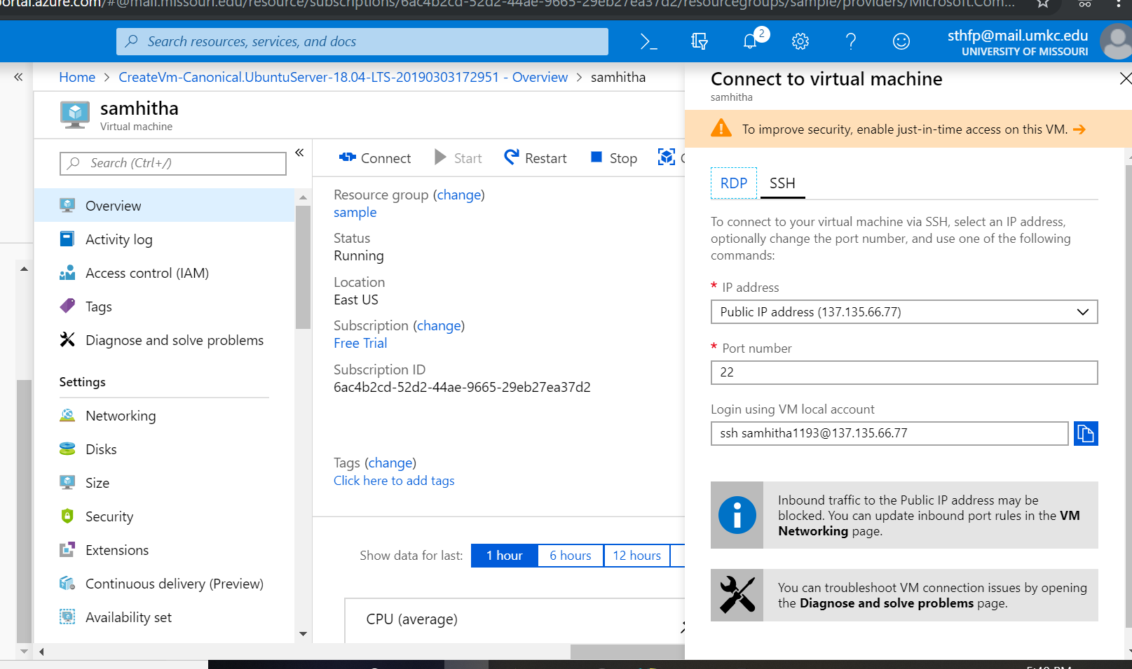

Open putty application and paste the URL in host name.

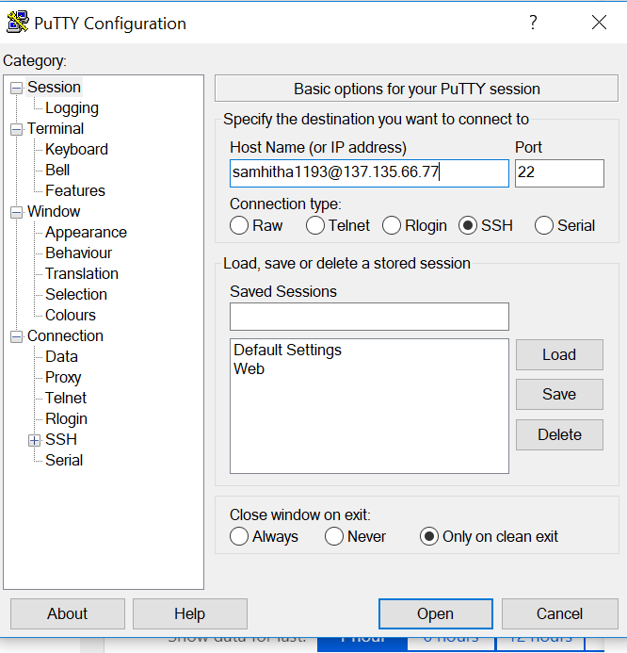

Azure prompt opened

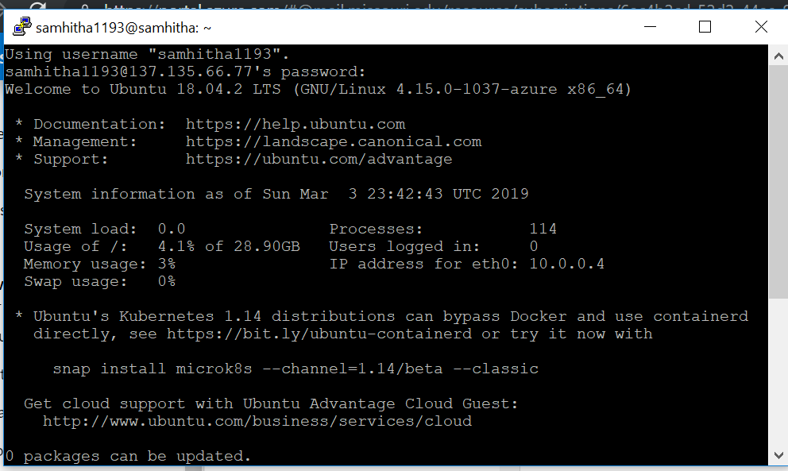

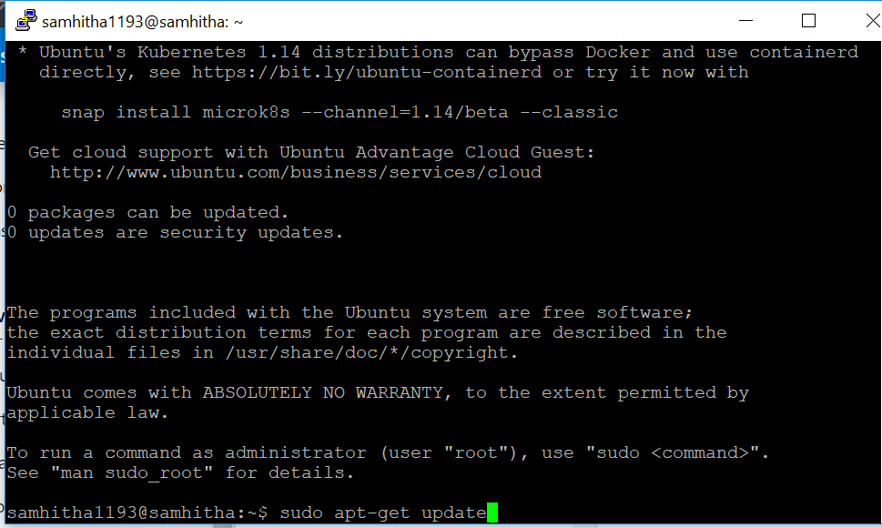

Install apache2

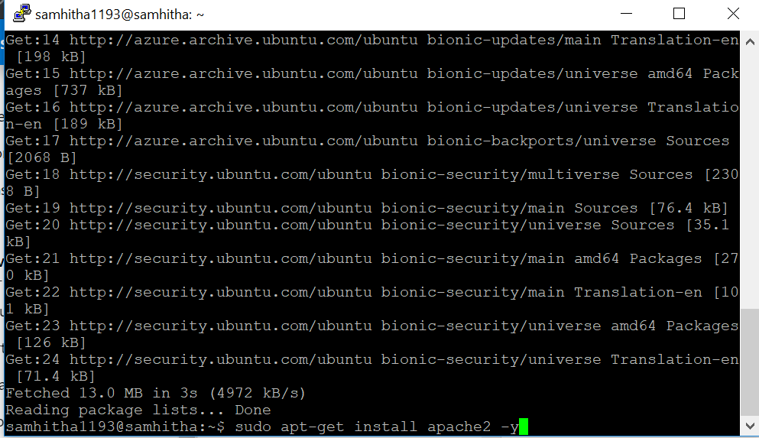

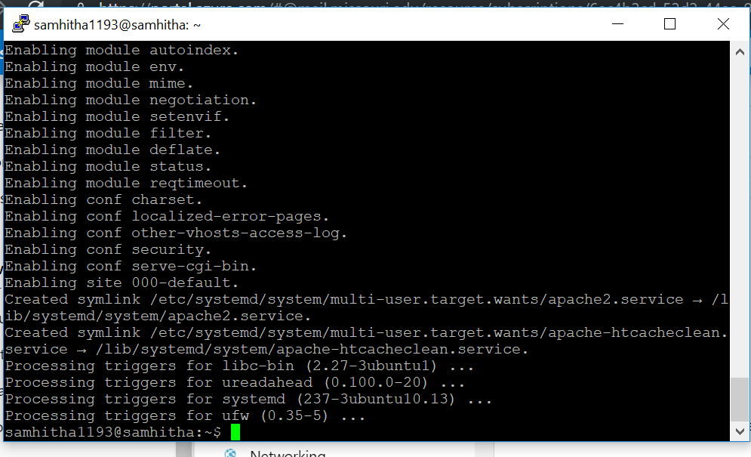

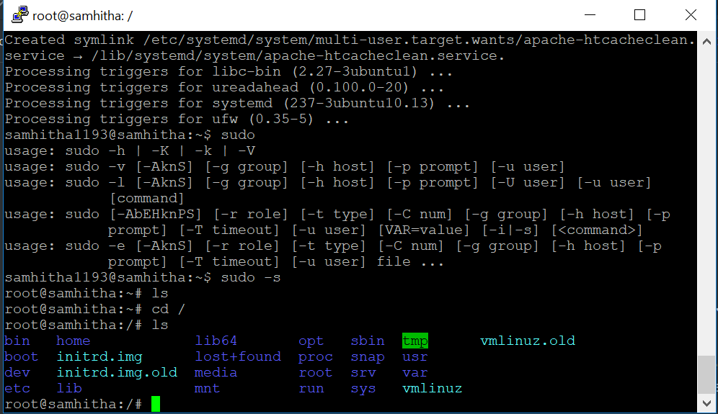

Open editor to edit code

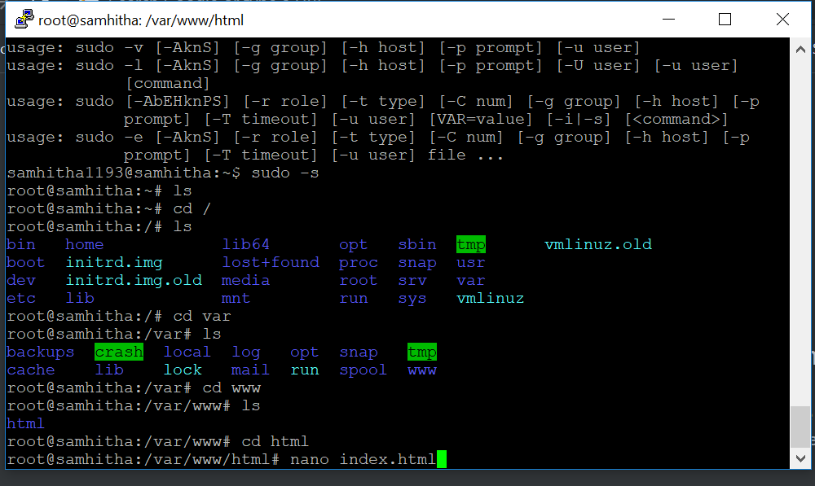

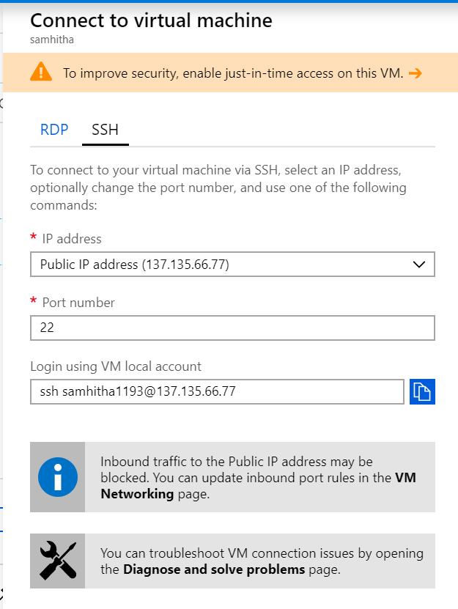

Web Server launched successfully

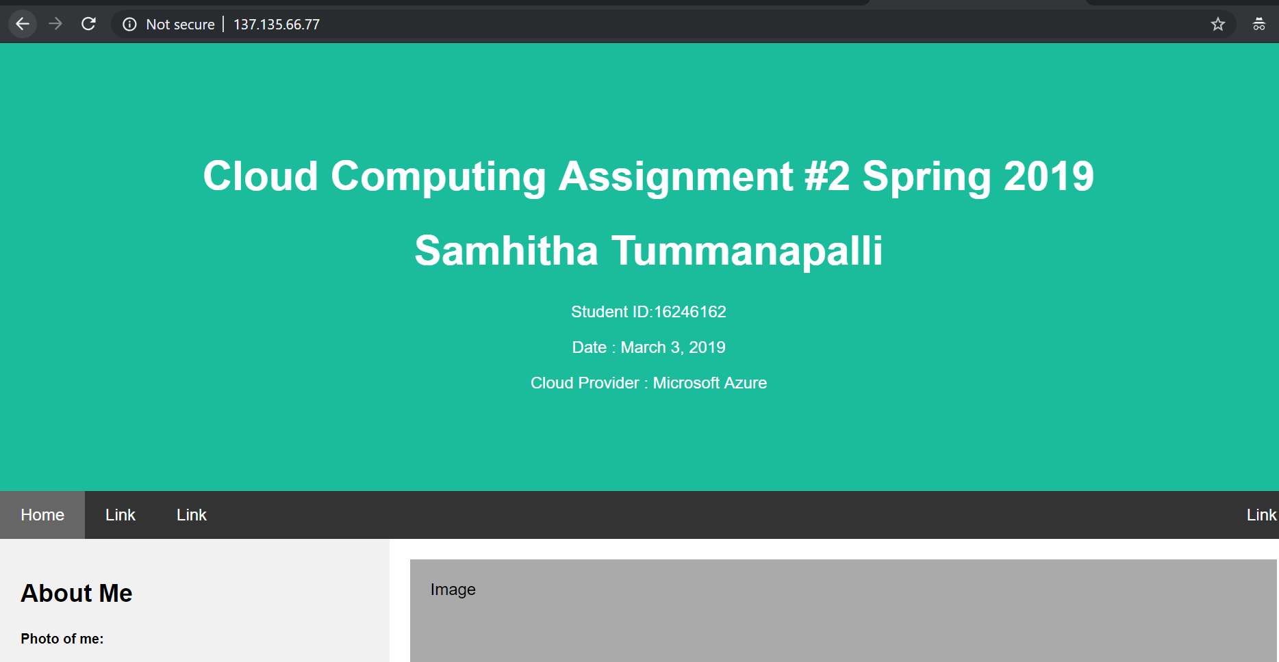

**Epilog:**

Google cloud platform provides $300 credit for 12 months. Setting up an account was easier when compared to AWS and Azure. I was able to access the platform as soon as I set up the account. It is easier to launch web server just by clicking on the external IP associated to the VM, instead of using another command. Putty application is not required to launch the prompt. Easy to edit the code using an editor. In my experience launching a web application on the Google Cloud platform VM. I found this easier when compare to AWS and Azure.

Amazon Web Services provide 12 months of free services with quite long hours to work with and after you exceed the limit you have an option to go with pay per service. Requires Puttygen application to convert .pem files to .ppk file and putty application to launch amazon prompt. Here we need to launch the web server using a command. I had difficulties in finding the command to use editor. In my experience I would prefer AWS next to GCP.

Microsoft Azure provide a service of 12 months of free services. But their free tier plans are confusing when compared to GCP and AWS. They provide a $200 credit which is valid for 30days only. So technically they are free only for a month. Like AWS this requires Putty application for window users to launch the Azure prompt. Easy to edit the code in an editor.